**CHAPTER ONE**

**INTRODUCTION**

**1.1 Background of the Study**

In many organizations, including tertiary educational communities, information management is one of the most substantial investments. Properly creating, maintaining, and retrieving information is crucial, particularly when it comes to students' records and examination data. Flawed student information management can lead to a plethora of errors in various educational processes. Virtually every facet of the educational system relies heavily on information processing. Introducing computer-based information processing capabilities can revolutionize these processes. With the aid of computers, educational institutions can achieve instant access to students' personal and course details, seamless updates of student information, automated computation of grades, efficient generation of graduating student lists, real-time monitoring of course performance, and the maintenance of an up-to-date student database that includes course information like subjects, descriptions, and grades for computation. Unfortunately, many educational institutions in the developing world, including universities, colleges of education, and Secondary School in Nigeria, continue to rely on manual methods for record-keeping and grade computation. (Mhaiskey et al., 2021)

Nowadays education plays a great role in the development of any country. Many of education organizations try to increase education quality. One of the aspects of this improvement is managing of school resources. However, “Talbelu Secondary School Ibeto” currently uses the manual method to process student registration, generate student admission numbers, and processing of student result and staff information management. (Akaiso et al., 2019)

(Ojo & Akhigbe, 2020), The profound effect of the application of computers in the management of school activities cannot be overemphasized, computer has been used to process student admission and registration, as well as their academic processes. Besides that the result of the student when fully computerized will be easier and quicker to process. The e-portal will be able to effectively and efficiently administer and manage the information in “Talbelu secondary school”.

Despite the main technological advancement in information technology over the past few decades, the typical management information at “Talbelu Secondary School Ibeto” has virtually remained unchanged. Any improvement in management could make significant contribution to improve the management system in the school. Currently this school does not use any kind of application system to assist in their daily activities, as is common in some schools and in developed countries. Hence the best step is to introduce an information management system for the school. (Mhaiskey et al., 2021)

In light of these challenges and the increasing demands for accuracy, efficiency, and accessibility in educational institutions, there is a pressing need to transition from outdated manual processes to automated systems. This transition not only addresses the persistent errors associated with manual record-keeping but also streamlines various administrative tasks and empowers both students and educational institutions with reliable, up-to-date information. This research endeavors to bridge this gap by designing and implementing an automated web-based examination result system tailored to the specific needs of educational institutions, with a focus on Talbelu Secondary School Ibeto as a case study. This system aims to revolutionize how student information is managed, courses are graded, and results are processed, ultimately enhancing the overall efficiency and effectiveness of the educational process. (Akaiso et al., 2019)

**1.2 Statement of the Problem**

At Talbelu Secondary School, the current manual system for processing and managing student records poses significant challenges. Students often experience delays in accessing their results, leading to issues with assessing their academic performance promptly. Furthermore, this manual approach introduces errors, including missing results, inaccuracies in grade calculations, and the risk of data loss due to potential disasters. These issues result in time wastage and data security concerns. An automated web-based examination system is urgently needed to address these challenges and provide accurate, efficient, and secure access to student information and academic records.

**1.3 Aim and Objectives of the Study**

The aim of the study is to develop a web-based examination results system for Talbelu Secondary School.

The objectives of this research work are as follows:

1. Present a single platform that will be used to manage the processing of all examination records within the school.
2. Design a web-based software with a simple and user-friendly interface that will be easy to use by ‘anybody’ with little computer knowledge.
3. Provide an effective, efficient, and error-free results processing system for the Polytechnic.

**1.4 Scope of the Study**

The scope of this project involves the development of a web-based examination results system specifically tailored for Talbelu Secondary School Ibeto. The system aims to address the challenges associated with the current manual processes for managing student records and examination data at the school. The primary focus is on creating a single platform that will streamline the processing of all examination records within the school, offering a more efficient, accurate, and accessible solution. The web-based software will be designed with a user-friendly interface to ensure ease of use for individuals with limited computer knowledge. The scope encompasses the entire results processing system within the school, aiming to enhance overall effectiveness and eliminate errors.

**1.5 Limitations of the Study**

This study's scope has been constrained by several issues, including:

**Time** - The researcher's busy academic pursuits severely limited the time allotted for research for this study.

**Finance** - The need for a standard working personal computer unit to execute and debug the application software, hindered the quick and simple progress of the task.

**1.6 Significance of Study**

The significance of this project work lies in its potential to bring about transformative improvements in the management of examination results at Talbelu Secondary School Ibeto. By developing a web-based examination results system, the project addresses the current challenges associated with manual processes, such as delays in accessing results, errors in grade calculations, and data security concerns. The significance extends to providing a more efficient, accurate, and secure platform for managing student records and examination data.

**1.7 Project Organization**

The project is divided into five chapters. The outlines are presented below:

**Chapter One: Introduction**

Chapter One introduces this project work, the background of the study, the statement of the problem, the aim and objectives, the scope of the study, the limitations of the study, the significance of the study, project organization, and the definition of terms.

**Chapter Two: Literature Review**

This chapter focuses on the literature review, and the contributions of other scholars on the subject matter being discussed.

**Chapter Three: Methodology and Design**

This chapter is concerned with the presentation of the results of system analysis and design. It presents the research methodology used in the development of the system to facilitate an understanding and effective future implementation of the system.

**Chapter Four: System Implementation Evaluation**

This chapter describes the system implementation and documentation, analysis of modules, and system requirements for implementation.

**Chapter Five: Summary, Conclusion, and Recommendation**

The chapter provides a summary of major findings, conclusions, and recommendations based on the study conducted.

**1.8 Definition of Terms**

1. **Website**: also written as web site, collection of related web pages, including multimedia content, typically identified with a common domain name, and published on at least one web server. (thefreedictionary.com 2011).
2. **Common Gateway Interface (CGI):** The common gateway interface (CGI) is a standard way for a Web server to pass a Web user's request to an application program and to receive data back to forward to the user.
3. **Information**: is any kind of event that affects the state of a dynamic system.
4. **Database**: it is a system intended to organize, store, and retrieve large amounts of data easily.
5. **Django:** Django is a free and open-source cross-platform web server solution stack package that encourages pragmatic design.
6. **User interface (UI):** The part of a software application that the user interacts with, including the layout, buttons, and other elements**.**
7. **User experience (UX):** The overall experience of a user interacting with a product or service, including their emotions, perceptions, and behaviours**.**

**CHAPTER TWO**

**LITERATURE REVIEW**

**2.1 Introduction**

The purpose of this chapter is to show how the problem under consideration relates to prior research, current practice, or other fields of knowledge by citing relevant works by other researchers who have dealt with a similar issue. Furthermore, this chapter will include a synthesis of current research on the issue, highlighting areas of agreement, disagreement, and gaps in the literature, to establish the significance of the project topic in the field and to recommend opportunities for future study.

**2.2 Literature Review**

(Akaiso & Mkpandiok, 2019). Result Processing System for Academic Institutions. This study addresses the fundamental issue of students' result processing and academic achievement information management in educational institutions. The existing system for handling academic results and transcripts was identified as tedious, time-consuming, and error-prone, particularly for a large number of students. To address these challenges, the research aimed to design a result-processing system for academic institutions. Data for system testing were collected from the semesters' results of ND and HND cadets in the departments of Nautical Science and Marine Engineering at the Maritime Academy of Nigeria, Oron, Akwa Ibom State. The system successfully computed the Grade Point Average (GPA) and Cumulative Grade Point Average (CGPA) for each cadet, providing easy access to all users at any time.

Furthermore, the research employed Object-Oriented Analysis and Design Methodology (OOADM) as the chosen approach for the system design. OOADM is a widely recognized technique for analyzing and designing applications, systems, or businesses, emphasizing object-oriented programming principles and visual modeling to enhance communication with stakeholders and overall product quality. The system design process followed the stages and principles of OOADM. For software implementation, the front-end interface was developed using hypertext markup language (HTML), cascading style sheet (CSS), and JavaScript, while the backend functionalities were implemented using hypertext pre-processor (PHP) and the MySQL database.

Moreover, the application described in this study presents significant potential benefits for tertiary institutions in terms of efficiently processing and managing students' academic records. It has the capacity to reduce costs associated with traditional result-processing methods. However, to further enhance the system's effectiveness, it is recommended that future research focuses on continuous improvement, updates, and adaptation to evolving technologies and educational needs. Additionally, research can explore the integration of advanced data analytics and security features to ensure data integrity and privacy.

In conclusion, one research gap worth addressing is the investigation of user experience and user interface design aspects of the system. A more in-depth analysis of how students, faculty, and administrative staff interact with the application and their feedback could lead to user-centric improvements. Moreover, exploring the scalability of the system for larger institutions and its compatibility with various educational management systems could be an area of future research interest.

(Ojo & Akhigbe, 2020). Modelling and Implementation of a Result Processing System. The study addresses the need for automating the manual result processing system in secondary schools, emphasizing efficiency and effectiveness. Utilizing the UML object-oriented methodology, the existing manual processes were analyzed, revealing inefficiencies. The system developed using technologies like PHP and MySQL offers a centralized repository for storing, managing, and distributing result information. It generates various reports in PDF format, including result summaries and broadsheets, making it adaptable for use in different public secondary schools.

Furthermore. the study employed the incremental development methodology for designing an e-result processing system for secondary schools in Ekiti state, Nigeria. Interviews with secondary schools informed requirement engineering. The chosen development model was incremental, well-suited for clear and understood requirements. The design phase used Unified Modeling Language (UML) tools, and implementation involved HTML, JavaScript, CSS, PHP, and MySQLi for front-end and back-end development. Beta testing was conducted. The system follows a three-tier client/server architecture using JavaScript, CSS, HTML, and PHP as core technologies.

Moreso, the software application developed in this paper offers significant benefits for processing and managing students' results in public secondary schools. It is recommended for adoption in Ekiti State's public secondary schools to address the challenges associated with manual result processing. Moreover, the software can be valuable for public secondary schools in other states of Nigeria, and its implementation should be considered.

In conclusion, while this research addresses the specific context of public secondary schools in Ekiti State, there is a potential research gap in exploring the adaptability and effectiveness of this software in a broader range of educational institutions, including private schools and schools in other Nigerian states. Additionally, further research could focus on the scalability and long-term sustainability of this software in handling increased data volumes as schools expand and evolve.

Mhaiskey et al. (2021). Android APP for Online Examination and Results Systems. The Online Examination System described in this paper offers a convenient and efficient solution for institutes and organizations to conduct and manage examinations over the internet, either through the web or a local area network (LAN). This system addresses common challenges encountered in traditional physical examination processes, such as result processing delays and record-keeping issues. It emphasizes the importance of online testing, highlighting its well-organized and resource-saving nature. The paper provides insights into the system's principles, primary functions, and security measures, making it a valuable tool for modern education and assessment.

Moreover, the online examination system employs a client/server architecture, facilitating connections via web browsers from clients, either through the internet or a local host. On the server side, PHP and MySQL are utilized to manage various examination processes, including exam preparation, data storage, retrieval, and database management. This methodology ensures efficient and secure handling of exams, offering a seamless experience for users connecting through web browsers.

In conclusion, the study recommends the implementation of the proposed Online Examination System (OES) in educational institutions, particularly universities and colleges, as it offers significant advantages in terms of exam security and flexibility. However, careful planning and user training should accompany the adoption process to ensure a smooth transition. Research gaps exist in relation to user experience and system optimization that need further exploration. Understanding user satisfaction, usability issues, and potential challenges during system implementation is crucial. Additionally, investigating the scalability of OES for accommodating various users and exam types is important. Research on user training and support mechanisms is also needed to ensure a smooth transition to the system and address any arising issues.

Matemilayo et al. (2019). An Online Result Processing and Transcript Generation System: A Case Study of Kwara State Polytechnic. This research introduces an online result processing and transcript generation system aimed at overcoming the tedious and time-consuming nature of the current manual method of handling academic results for a large number of students. The system demonstrated effective performance during testing, leading to its online launch for easy access by users. The developed application not only reduces the cost and time associated with information processing but also enhances accuracy, and efficiency, and eliminates redundancies. Moreover, the system's adaptability makes it applicable to any polytechnic with a similar grading system.

Furthermore, the system was developed using structured system analysis and design methodology on a web-based platform. The front-end interface utilized HTML5, CSS3, and JavaScript, while PHP served as the server-side scripting language, and MySQLi was employed as the relational database management system. PHP's flexibility and feature set made it the preferred choice for creating online and offline applications. System design focused on coordinating activities, procedures, and equipment to achieve research objectives, with a primary emphasis on output determination.

In conclusion, the research recommends implementing this automated information management system in tertiary institutions with similar grading systems. The system's efficiency, cost reduction, and speed in processing student results make it a valuable addition to the educational environment. It eliminates the need for manual processing, reducing human error and resource duplication. The research gap in this context pertains to the limited focus on automated information management systems for result processing in tertiary institutions with similar grading systems. Further exploration is needed to assess the system's adaptability to various grading systems, scalability to accommodate larger student populations, and its impact on reducing administrative burdens and resource consumption in diverse educational settings. Additionally, the potential challenges, user experiences, and long-term sustainability of such systems warrant more in-depth investigation to bridge this research gap effectively.

Okechukwu et al. (2020). An Enhanced Result Processing and Checking System for Public Universities using 2FA and TOTP. This research addresses the prevalent challenges in result processing and checking faced by public universities in Nigeria and introduces an advanced online system to overcome these issues. It incorporates two-factor authentication for user identification, streamlining course registration, result collation, grading, publishing, and management decisions. Evaluation results demonstrate the system's significant advantages in terms of information quality, speed, security, user-friendliness, and time efficiency. Moreover, the financial analysis underscores its positive net present value (NPV) and impressive return on investment (ROI), emphasizing the potential for widespread adoption and enhancement of result processing systems in similar contexts.

Moreover, this study focused on two Nigerian universities, NOUN and FUTO, known for their academic excellence. NOUN had a computerized result system with challenges, while FUTO relied on manual processes. Data collection used questionnaires, interviews, electronic methods, and document examination, employing the Delphi method to gather expert opinions. Technologies like Microsoft ASP.Net, JavaScript, XML, Java, HTML, CSS, JSON, JQuery, Web-API, and Android were used to develop an enhanced online result system to address these challenges.

In conclusion, the proposed enhanced online system significantly outperforms the existing one based on these KPIs. Therefore, it is strongly recommended that public universities in developing countries, particularly Nigeria, adopt the proposed system to enhance the effectiveness and efficiency of their result processing and checking procedures. While the study proposes an enhanced online system that significantly improves on these KPIs, there is a notable research gap in terms of the broader adoption of such systems across the educational landscape. Further research could explore the challenges and barriers hindering the implementation of advanced result processing and checking systems in public universities, potentially paving the way for comprehensive improvements in the education sector

**2.3 Summary of Related Literature Reviews**

|  |  |  |
| --- | --- | --- |
| **Author & Year** | **Title & Description** | **Merit and Demerits** |
| (Akaiso & Mkpandiok, 2019). | Result Processing System for Academic Institutions.  This study addresses the fundamental issue of students' result processing and academic achievement information management in educational institutions. | The program is both effective and efficient in accomplishing project objectives while also being user-friendly.  A high influx of users might slow system performance. |
| (Ojo & Akhigbe, 2020). | Modeling and Implementation of a Result Processing System.  The study addresses the need for automating the manual result processing system in secondary schools, emphasizing efficiency and effectiveness | The system addressed the inefficiencies of manual processes and provided a centralized repository for result information.  The system might lack scalability |
| Mhaiskey et al. (2021). | Android APP for Online Examination and Results Systems.  The Online Examination System described in this paper offers a convenient and efficient solution for institutes and organizations to conduct and manage examinations over the Internet, either through the web or a local area network (LAN). | This system addresses common challenges encountered in traditional physical examination processes, such as result processing delays and record-keeping issues  Security threat as users’ information is stored in its session as long as possible unless they are manually logout. |
| Matemilayo et al. (2019). | An Online Result Processing and Transcript Generation System: A Case Study of Kwara State Polytechnic.  This research introduces an online result processing and transcript generation system aimed at overcoming the tedious and time-consuming nature of the current manual method of handling academic results for a large number of students | The system reduces the cost and time associated with information processing but also enhances accuracy, and efficiency, and eliminates redundancies.  Other hurdles revealed by the research include the visual style of the web interface, which may pose problems for its users. |
| Okechukwu et al. (2020). | An Enhanced Result Processing and Checking System for Public Universities using 2FA and TOTP.  This research addresses the prevalent challenges in result processing and checking faced by public universities in Nigeria and introduces an advanced online system to overcome these issues. | The system incorporates two-factor authentication for user identification.  The implemented system is a local host platform, which is not ideal for any project unless under development. |

**2.4 Manual Result Processing**

Manual result processing involves the traditional method of handling academic results without the use of automated systems. Some of the limitations associated with manual result processing include:

1. **Time-Consuming**: Manual result processing is often time-consuming, especially when dealing with a large number of students. The need to manually calculate grades, compute grade point averages, and generate transcripts for each student can lead to delays in providing timely academic information.
2. **Error-Prone**: The manual process is susceptible to errors such as miscalculations, data entry mistakes, and inaccuracies in result computation. These errors can affect the reliability and accuracy of academic records.
3. **Tedious and Cumbersome:** Processing academic results manually can be a tedious and cumbersome task, requiring significant human effort. This can lead to fatigue and a higher likelihood of errors as individuals engage in repetitive and monotonous tasks.
4. **Limited Accessibility:** Manual records are often stored in physical formats, making them less accessible compared to digital systems. Retrieving information from manual records may require physical presence, limiting accessibility for stakeholders.
5. **Storage and Retrieval Challenges:** Storing and retrieving manual records, especially in paper-based formats, can pose challenges. The risk of misplacement, damage, or loss of records due to environmental factors or accidents is a concern.

Addressing these limitations through the implementation of automated and digital result-processing systems can enhance efficiency, accuracy, and accessibility in managing academic records.

**2.5 Analysis of the Existing System**

In Talbelu Secondary School, records are being kept manually on papers for both the students and the staff which are highly unsecured and can be destroyed or altered easily. Furthermore, all the processes of those records are also highly time-consuming. Likewise, the result computation and compilation are very tedious and cumbersome task that is associated with a lot of human error.

According to Muhammad Wakil (principal), it takes (class teacher) much time before they process the students’ tests, assignments, and exams to produce report for a class. This is one of the reasons why students’ results are not given to them on the specified time (end of term). This difficult task affects the teachers’ preparations against next term since they covered their work very late. Hence, this process continued as the number of students are increasing. These make the teachers unhappy with their work. Imagine a teacher compiling just 30 students results and the stress the teacher has to undergo. The teacher gets busy calculating (addition and division) each student’s test and exam scores. For every student, the teacher will add what the student scored in assignment, test and exam to get the total for that subject, assume the subject is Mathematics; the teacher will repeat it for the rest subjects offered by the student just to get all the total scores for each subject. To get the average score for this student, the teacher will have to add all the total scores for each subject offered and then divide by total number of subjects offered by the student. The same process is repeated for the remaining 29 students. The teacher will also enter the record into each student's “Report Card” then create a broad sheet called Master Sheet for all the students’ records for future reference. This is stressful and time-consuming, in order to manage this computation and to make teachers less stressed, make their job enjoyable and to make them direct their attention on teaching is very easy with computerized system.

**2.6 Analysis of the New Proposed System**

The proposed system involves the development and implementation of an online result processing and transcript generation system, aiming to address the limitations of the existing manual result processing system in secondary schools.

Our proposed system has several advantages

1. User friendly interface.
2. Fast access to database.
3. Less error.
4. More Storage Capacity.
5. Real-Time Result Computation.

**CHAPTER THREE**

**METHODOLOGY AND DESIGN**

**3.1 Introduction**

A methodology is a rigorous study or inquiry, particularly to unearth new facts or information; thus, research methodology should be good enough to enable the achievement of the specified objectives, which are achievable using specific components, such as data collection and design procedures, and system modeling (use case, activity, and class diagrams). This chapter provides the input/output specifications as well as the system requirements for the development of an exam result processing system.

**3.2 Methods of Data Collection**

Before constructing any system, it is necessary to collect data and facts about the existing system to comprehend what is going on. Two approaches were used in this study.

1. Observation of the Work Environment
2. Documentation

**3.2.1 Observation of the Work Environment**

By monitoring how the manual system worked, this method was employed to acquire information and data for this study. A careful review highlighted the most evident flaws in the current system. When utilizing the observational approach, the environment in which the observation is taken can be changed in a variety of ways.

**3.2.2 Documentation**

Documentation is part of secondary data collection. In this case, journals, manuals, past work, publications, and other sources are utilized. This method of data collection was chosen because it allows for comparison with past studies. This includes the internet, which is a data collection tool. The internet was used to study difficult or ambiguous situations.

**3.3 System Modeling**

A system model is a conceptual model of a system that explains and depicts it. A system is any interaction between a group of components that work together to achieve a common purpose. A collection of visual notation techniques inherent in the Unified Modeling Language, which was used to design this current system, may be used to construct visual models of object-oriented software-intensive systems. UML diagrams utilized in this new design include use case diagrams, class diagrams, and activity diagrams.

**3.3.1 Use Case Diagrams**

Use cases are groups of interactions between a system and a user. Use case diagrams are used to graphically portray the functioning of a system in terms of its actors, goals (expressed as use cases), and dependencies between those use cases.

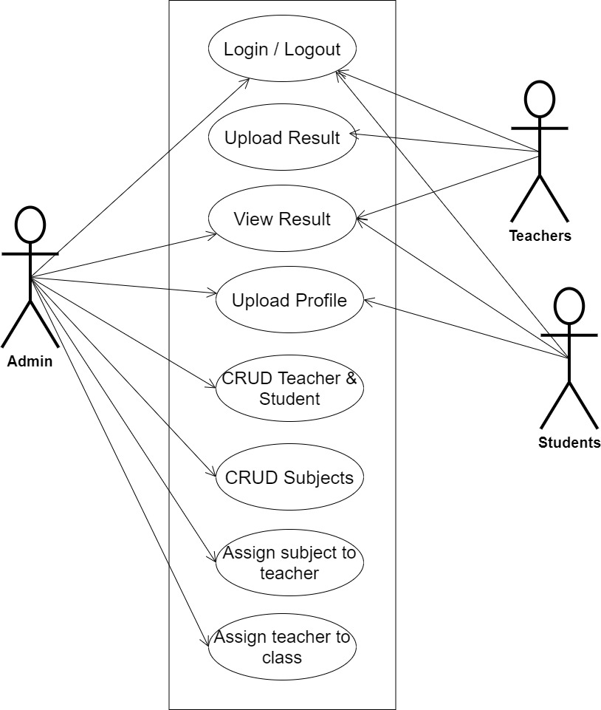

**Fig 3.1 System Use Case Diagram**

**3.3.2 Class Diagrams**

The Unified Modeling Language (UML) class diagram is an implementation of an independent view of how the system interface might appear, with each class having its own set of properties and displaying how they interact with one another. Class diagrams use the Unified Modeling Language standards to visually depict a given system's static structure and composition (UML).

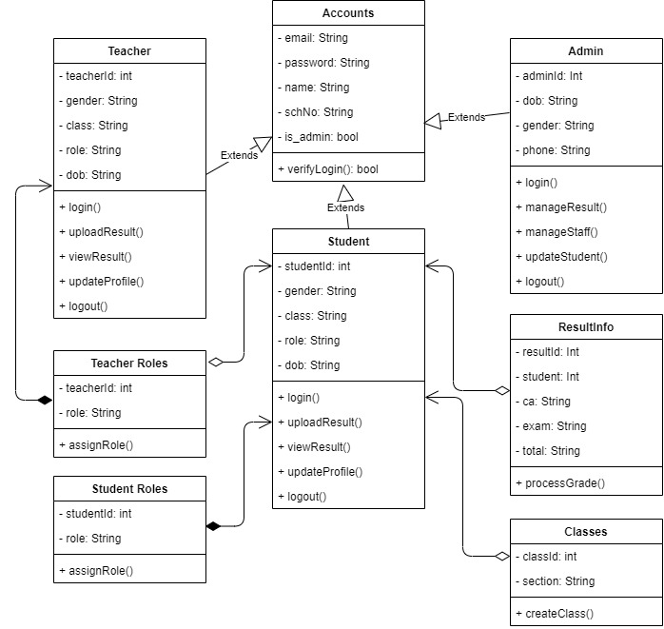

**Fig 3.2 System Class Diagram**

**3.3.3 Activity Diagrams**

An activity diagram, like a flowchart or a data flow diagram, visually illustrates a series of events or the flow of control in a system, but it acts more like an enhanced version of both.

**Login**

The process for gaining access to the system is depicted in the diagram below; the email address and password must be accurate to gain access.

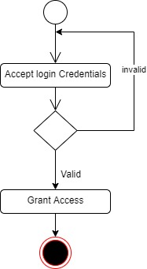

**Fig 3.3.1 Login Activity Diagram**

**Uploading Grades**

The process for uploading grades is depicted below, to upload student grade one has to be authenticated.

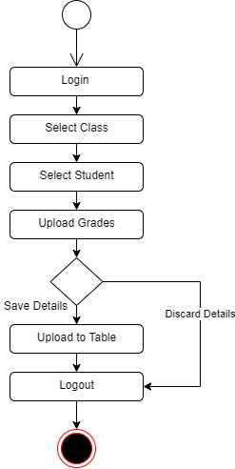

**Fig 3.3.1 Upload Grades Activity Diagram**

**3.4 Database Design**

Input specification is the logical explanation of how data is stored in the computer's memory. SQL standards are vital for guaranteeing that structured data is uniform and independent of applications due to the flexibility experienced when using the system, as well as the simplicity of accessing and reading the data and ensuring applicability throughout the internet. The following are some of the input specifications used in this project effort.

1. Users Table: contains basic information about all system users (Admin, Staff, Student).
2. Result Table: contains needed information for processing students results.

**Table 3.1 Account Table input specification table**

|  |  |  |  |  |  |
| --- | --- | --- | --- | --- | --- |
| **FIELD NAME** | **DATA TYPE** | **NULL** | **KEY** | **LENGTH** | **DESCRIPTION** |
| Email | String | No |  | 150 | Email for login (case sensitive) |
| Password | String | No |  | 150 | Access Code (case sensitive) |
| name | String | No |  | 150 | Full name of the user |
| schNo | String | No |  | 10 | Unique string to identify users |
| is_admin | Boolean | No |  | 1 | Key for identifying admin |
| acct_id | String | No | PK | 64 | A unique string for identifying users |

**Table 3.2 Result Input Specification Table**

|  |  |  |  |  |  |
| --- | --- | --- | --- | --- | --- |
| **FIELD NAME** | **DATA TYPE** | **NULL** | **KEY** | **FIELD SIZE** | **DESCRIPTION** |
| Student_id | String | No | FK | 10 | A unique string for identifying student |
| Ca | String | No |  | 10 | Student continuous assessment score |
| exam | String | No |  | 10 | Student exam score |
| total | String | No |  | 10 | Student total score |
| Result_id | int | No | PK | 1 | A unique number for identifying results |

**3.5 Output Design**

This declares and displays the outcome of the given input. This automated system's output is dependent on its input. The output specification is listed below

**Table 3.3 Account Table**

|  |  |  |  |  |  |
| --- | --- | --- | --- | --- | --- |
| **Email** | **Password** | **Is_Admin** | **Acct_id** | **Name** | **SchNo** |
| XXXX | XXXX | XXXX | XXXX | XXXX | XXXX |
| XXXX | XXXX | XXXX | XXXX | XXXX | XXXX |
| XXXX | XXXX | XXXX | XXXX | XXXX | XXXX |
| XXXX | XXXX | XXXX | XXXX | XXXX | XXXX |

**Table 3.4 Result Table**

|  |  |  |  |  |
| --- | --- | --- | --- | --- |
| **Result_id** | **Student_id** | **CA** | **Exam** | **Total** |
| XXXXX | XXXXX | XXXXXX | XXXXX | XXXXX |
| XXXXX | XXXXX | XXXXXX | XXXXX | XXXXX |
| XXXXX | XXXXX | XXXXXX | XXXXX | XXXXX |
| XXXXX | XXXXX | XXXXXX | XXXXX | XXXXX |

**3.6 Input & User Interface Design**

This is a graphic depiction of the system interface; it will be designed to be user-friendly, responsive, and visually beautiful. Furthermore, it will be fully secured, thus authentication will be required to see various levels of the information. To help with the designs, a mid-fidelity wireframing program called Draw.io is employed.

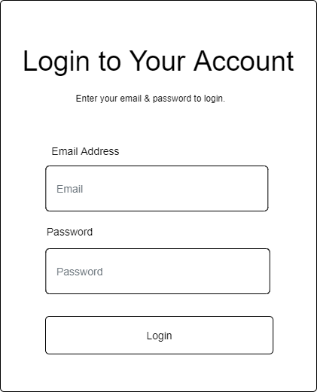

**Figure 3.6.1 User Login Page**

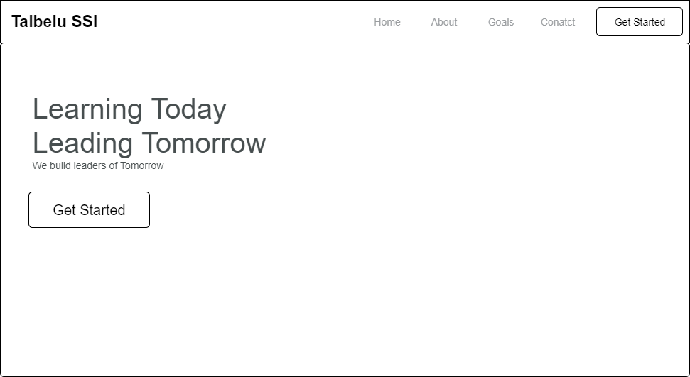

**Figure 3.6.2 Home page**

**3.7 System Requirement**

Every piece of software-generated has predefined system requirements that it must fulfill to function properly. The system requirements, on the other hand, are the bare minimum of hardware and software required for the system's intended operation.

**3.7.1 Hardware Requirement**

System Hardware Requirement Include:

1. Minimum of 2 GB of RAM (Random Access Memory).
2. Minimum of Intel Dual core processor.
3. Minimum of 250GB HDD (Hard Disk Drive).

**3.7.2 Software Requirement**

The software requirements include:

1. At least Windows 7 OS (Operating System).
2. Vs. Code IDE installation.
3. Browsers include Chrome and Firefox.

**3.8 Choice of Programming Language**

This research work will be a mobile-based application and will be implemented on a relational database system (SQLite). HTML, CSS, and JavaScript will be employed in the front end while Django (python) will be employed for the backend programming. The above are the modern languages used in implementing this system.

**REFERENCES**

Akaiso, L. E., & Mkpandiok, M. A. (2019). Result Processing System for Academic Institutions.

International Journal of Scientific & Engineering Research, 10(5), 132–150. Retrieved from http://www.ijser.org

Mhaiskey, M. P., Thombare, M. R., Patle, N. M., Gujarkar, K. S., & Rewatkar, A. (2021). Android

APP for Online Examination and Results Systems. International Journal of Scientific Research & Engineering Trends, 7(3), 2395–566.

Matemilayo, D. O., Kamaldeen, R. A., & Samson, O. F. (2019). An Online Result Processing and

Transcript Generation System: A Case Study of Kwara State Polytechnic. Kwarastatepolytechnic.Edu.Ng, 5(1). Retrieved from https://kwarastatepolytechnic.edu.ng/publication/An%20Online%20Result%20Processing.pdf

Okechukwu O. Anyiam, Ugochi A. Okengwu, & Francisca N. Anyiam. (2020). An Enhanced

Result Processing and Checking System for Public Universities using 2FA and TOTP. International Journal of Engineering Research And, V9(02). https://doi.org/10.17577/ijertv9is020111

Ojo, O., & Akhigbe, B. (2020). Modelling and Implementation of a Result Processing System.

ScienceOpen Preprints, (August), 0–1.